DEDALO MINOSSE INTERNATIONAL PRIZE
FOR COMMISSIONING A BUILDING
SEVENTH EDITION 2007/2008

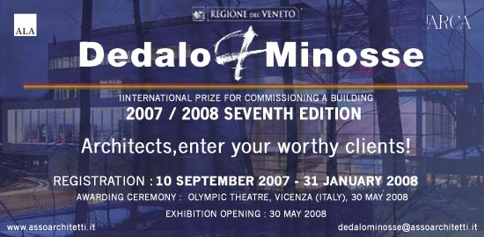

Event program:

- Subscription campaign: 10th September 2007 – 31st January 2008
- Jury’s meeting: 15th February 2008, Vicenza
- Round table: 29th of May 2008, Vicenza
- Press conference: 30th of May 2008, Vicenza
- Awarding ceremony: 30th of May 2008, Olympic Theatre by Andrea Palladio, Vicenza
- Exhibition opening: 30th of May 2008, Vicenza
- Guided tour of Vicenza monuments and sites: 31st of May 2008, Vicenza

Free registration is open to private and public clients from all over the world. The commissioned architeture works must have been designed by a professional architect or a building engineer and been completed over the last five years.

There are 4 main awards and other special awards conferred by the review l’ARCA, the main sponsor Caoduro Lucernari and by other Patron Bodies and Supporters. Among the special awards, one is dedicated to Italian architects and another one to young architects or rather to Clients who commissioned works to under 40 professional architects.

The winning works will be exhibited internationally and published on a limited edition catalogue edited by l’ARCA Edizioni. Moreover, a booklet with a selection of works will be internationally distributed attached to more than 45.000 copies of the review l’ARCA. Thanks to the Prize’s international communication channels, details and information about prize-winners, other selected entrants and their works will be promoted worlwide.

Information:

Dedalo Minosse International Prize
Organizing Office
ph. and fax n. +39 (0)444 235476
http://www.assoarchitetti.it
mail to: dedalominosse@assoarchitetti.it

